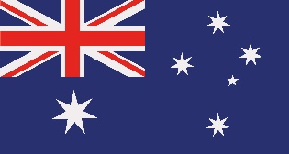
Funny Australian Phonetic Alphabet
A | AUSTRALIA | N | NEMO
B | BRUCE | O | OUTBACK
C | CRIKEY | P | PERTH OR PLATYPUS
D | DUNNY | Q | QUEENSLAND
E | EMU | R | ROO
F | FOOTIE | S | SHEILA
G | G’DAY | T | TINNY
H | HOTEL | U | ULURU
I | IFFY | V | VICTORIA
J | JELLYFISH | W | WOMBAT
K | KANGAROO | X | X-RAY
L | LYREBIRD | Y | YABBY
M | MELBOURNE | Z | ZULU

